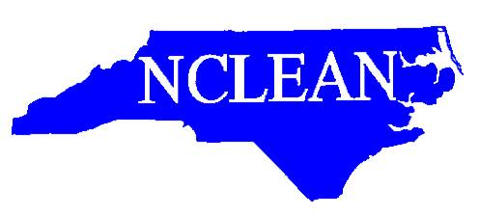
NCLEAN 2021 Annual Training Conference Registration Form
September 26th --September 29th

We have planned a great three-day schedule of training that should be beneficial for agencies. Please make sure that you go ahead and register for the NCLEAN Annual Training Conference and make your hotel reservations by August 31, 2021. The host hotel is the Marriott Courtyard Carolina Beach, 100 Charlotte Ave Carolina Beach, NC 28428. The link in the email sent out on 2/26/21 will take you directly to the NCLEAN group bookings. Group Name is the North Carolina Law Enforcement Network. If you would rather make a reservation by phone the number is 888-616-4655. The room rate is $139 per night plus tax. This rate includes a hot breakfast in the Bistro. This rate is good for September 24th through October 1st. Reservations for this block must be made by August 30, 2021.

AGENCY:
NAME & EMAIL:
NAME & EMAIL:
NAME & EMAIL:

Attach additional sheets as needed for attendees.

Registration is $50.00 for each attendee from your agency. Total Amount Enclosed:
To pay your registration with a credit/debit card, please call Ricky Buchanan at 919-224-6821.
Payments may also be made at the registration table at the conference on Sunday afternoon or Monday morning.
Please send the registration form in advance, even if you plan to pay at the door, so that we have a head count for training and food.

We ask each agency to please bring a door prize to add to our drawings!!
Please mail this form and payment to:
NCLEAN Treasurer
c/o Ricky Buchanan
5200 Red Mill Road
Durham, NC 27704

